**Company queries 12 to 19**

**12. For every project located in 'Stafford', list the project number, the controlling department number, and the department manager's last name, address, and birthdate.**

select pnumber,dnum,lname,address,bdate from employee,project,department where dnum=dnumber and mgr_ssn=ssn and plocation='stafford';

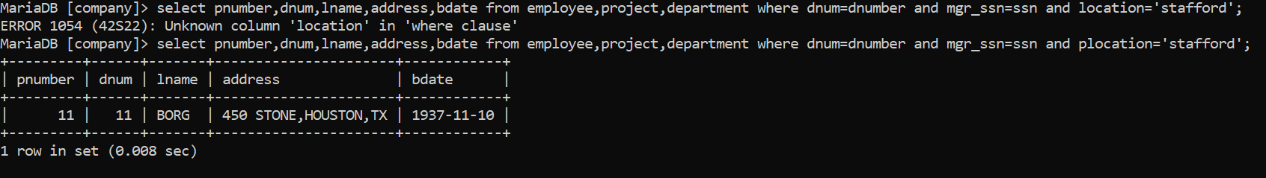

**13. For each employee, retrieve the employee's name, and the name of his or her immediate supervisor.**

SELECT E.FNAME,E.LNAME,.S.FNAME,S.LNAME FROM EMPLOYEE AS E,EMPLOYEE AS S WHERE S.SUPER_SSN=E.SSN;

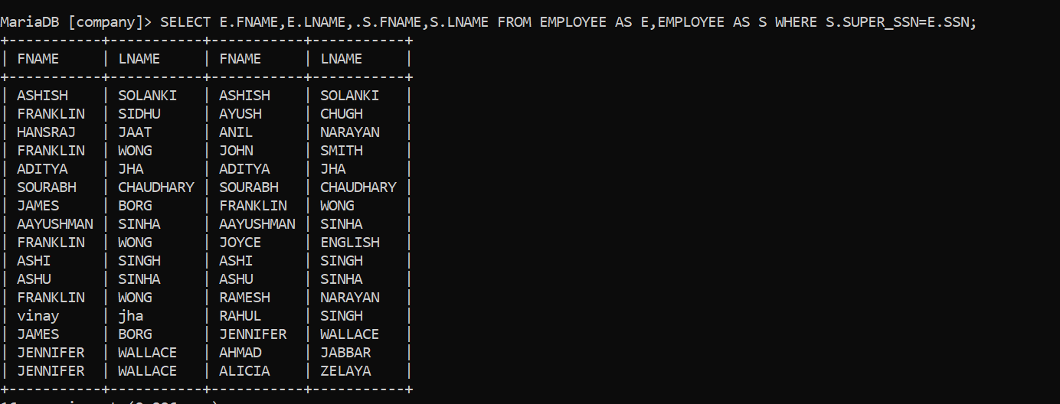

**14. Retrieve all combinations of Employee Name and Department Name**

select concat(fname,' ',minit,' ',lname)as name,dname as department_name from employee,department;

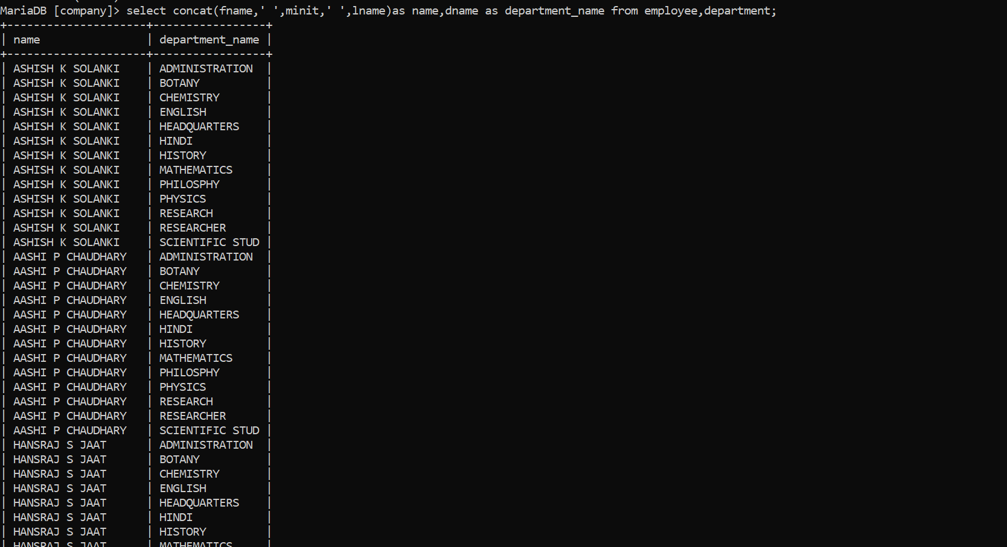

**15. Make a list of all project numbers for projects that involve an employee whose last name is 'Narayan’ either as a worker or as a manager of the department that controls the project**

(select distinct pnumber from project,department,employee where dnum=dnumber and mgr_ssn=ssn and lname='narayan') union (select distinct pnumber from project,works_on,employee where pnumber=pno and essn=ssn and lname='narayan')

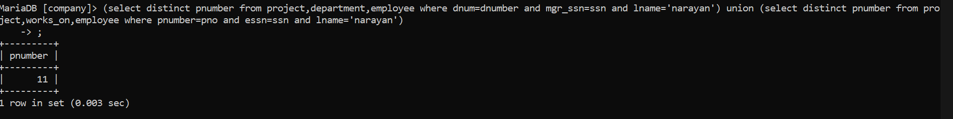

**16. Increase the salary of all employees working on the 'ProductX' project by 15% . Retrieve employee name and increased salary of these employees.**

UPDATE employee SET salary=1.15*salary WHERE Dno=(SELECT Dnum FROM Project WHERE Pname="ProductX");

select salary from employee where Dno=(SELECT Dnum FROM Project WHERE Pname="ProductX");

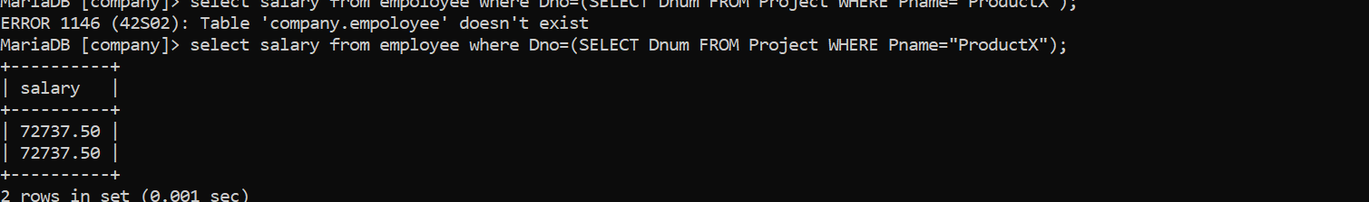

**17. Retrieve a list of employees and the project name each works in, ordered by the employee's department, and within each department ordered alphabetically by employee first name.**

SELECT DNAME,FNAME,LNAME,PNAME FROM EMPLOYEE,WORKS_ON,DEPARTMENT,PROJECT WHERE SSN=ESSN AND DNO=DNUMBER AND PNO=PNUMBER ORDER BY DNAME,LNAME,FNAME ASC;

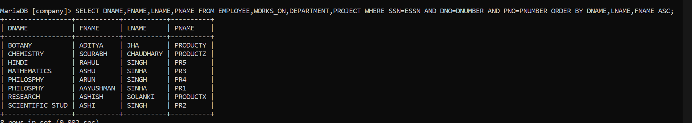

**18. Select the names of employees whose salary does not match with salary of any employee in department 10**

**SELECT FNAME,MINIT,LNAME FROM EMPLOYEE WHERE SALARY NOT IN (SELECT SALARY FROM EMPLOYEE WHERE DNO='10');** 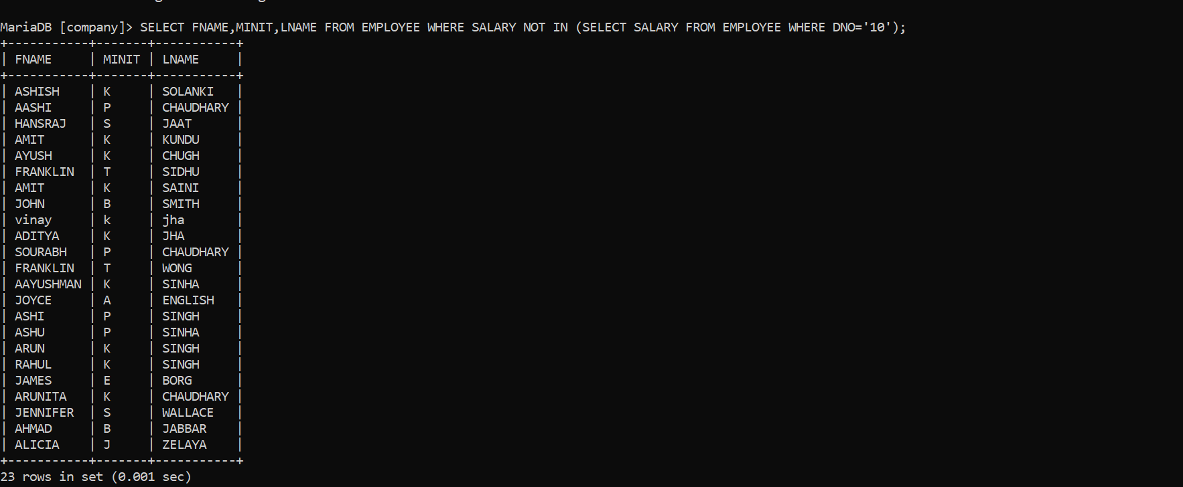

**19. Retrieve the name of each employee who has a dependent with the same first name and same sex as the employe**

**select e.fname,e.lname from employee as e,dependent as d where e.ssn=d.essn and e.sex=d.sex and e.fname=d.dependent_name;**

